STEP 1 : Select Storage from category and choose S3 (Scalable Storage in the Cloud)

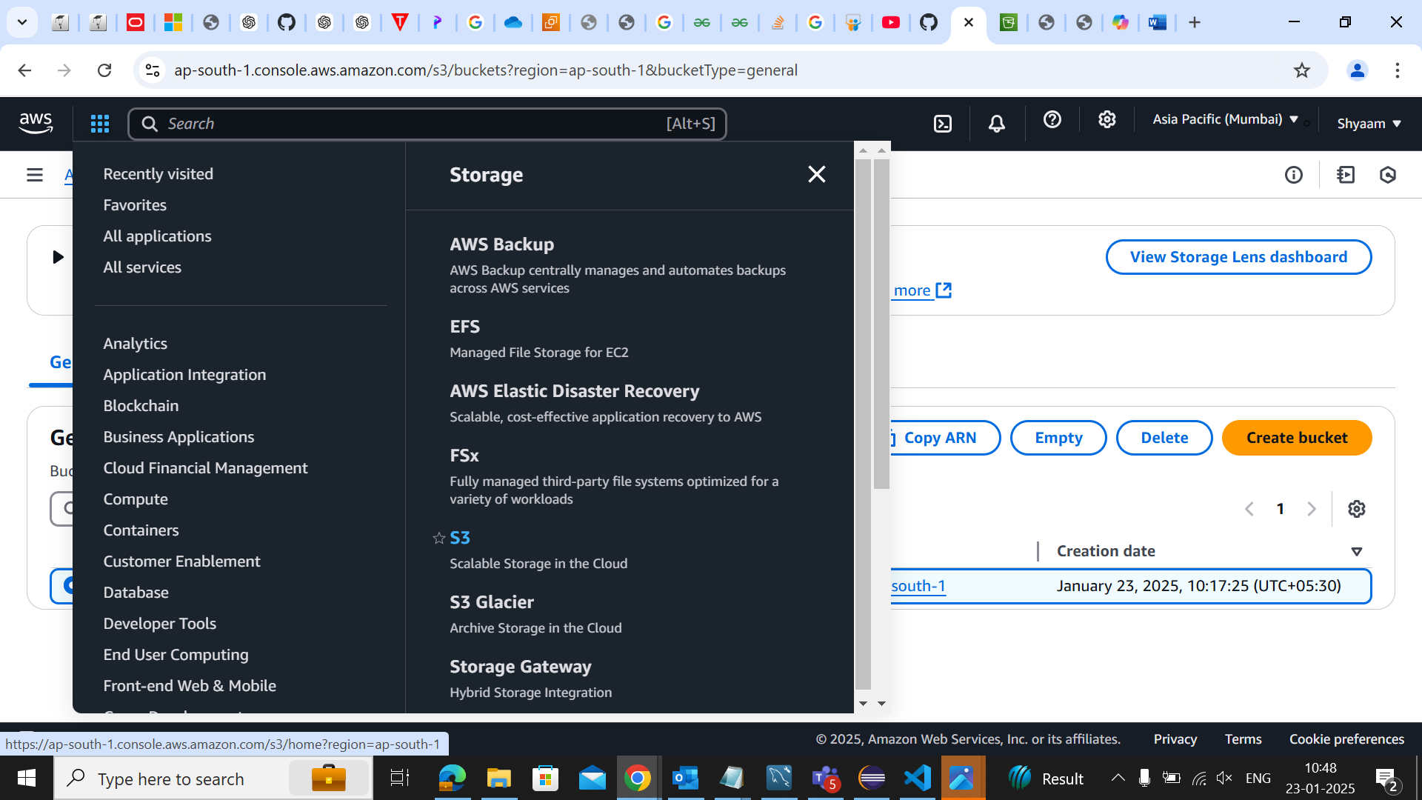

STEP 2 : Create Bucket

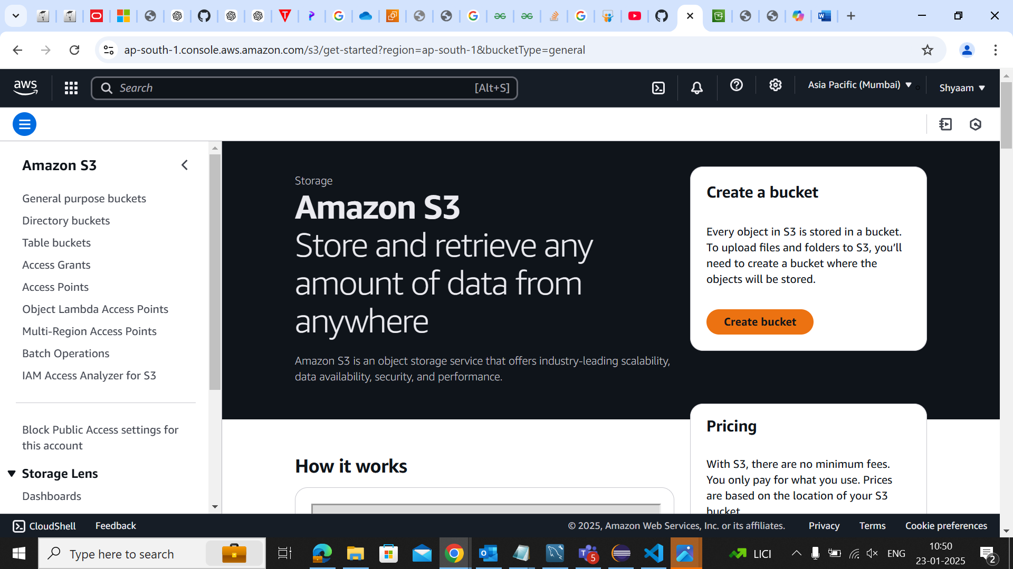

Step 3: Bucket Created

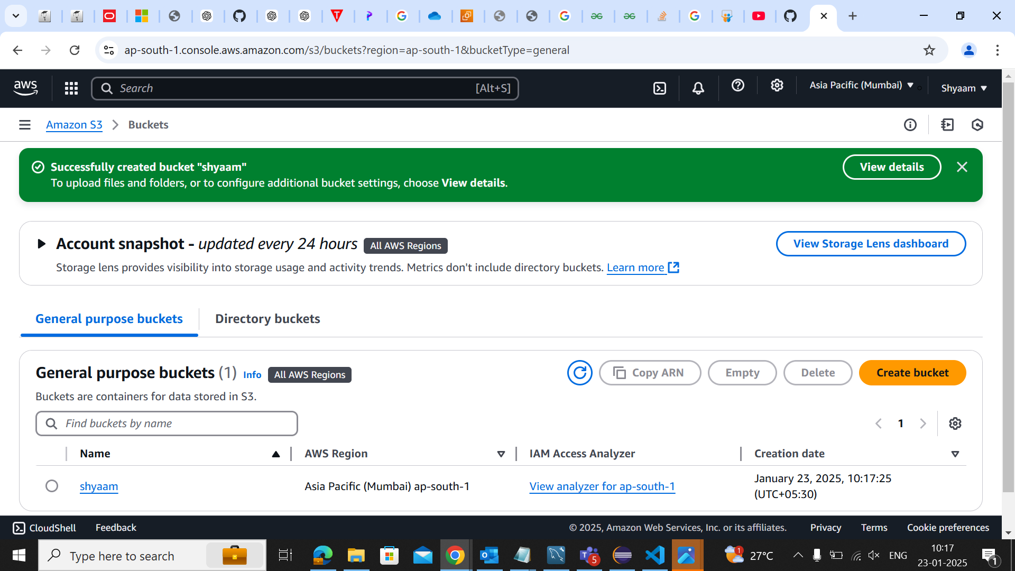

Step 4 : Uploaded Document in the Bucket

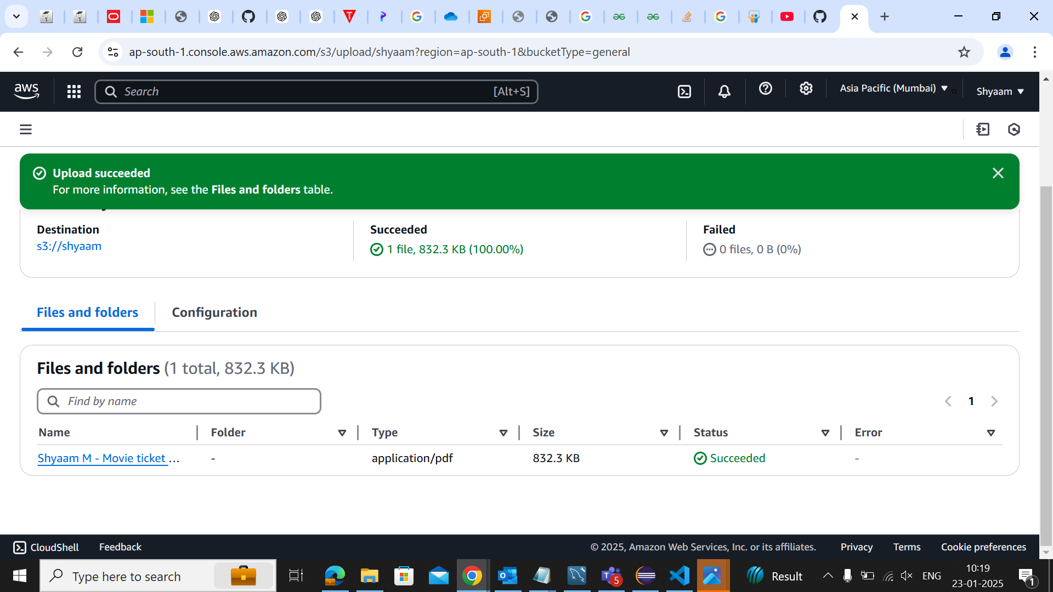

Step 5 : Acess Denied at first

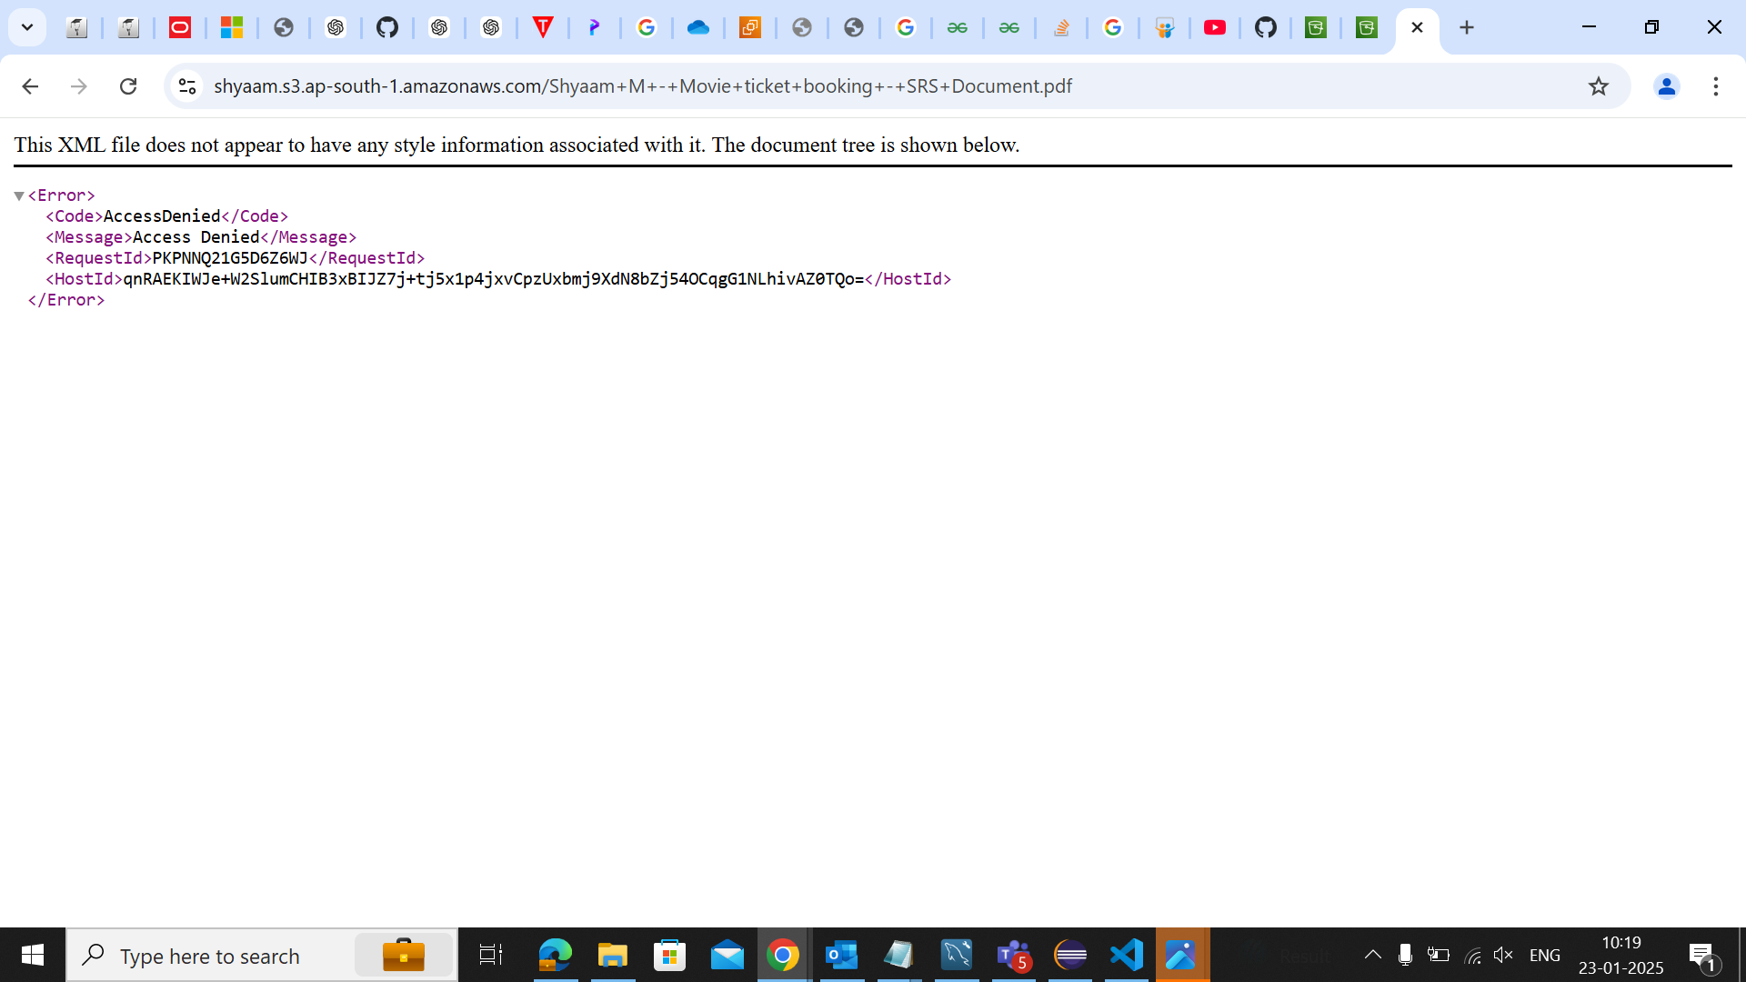

Step 6 : Setting Time interval to display the document

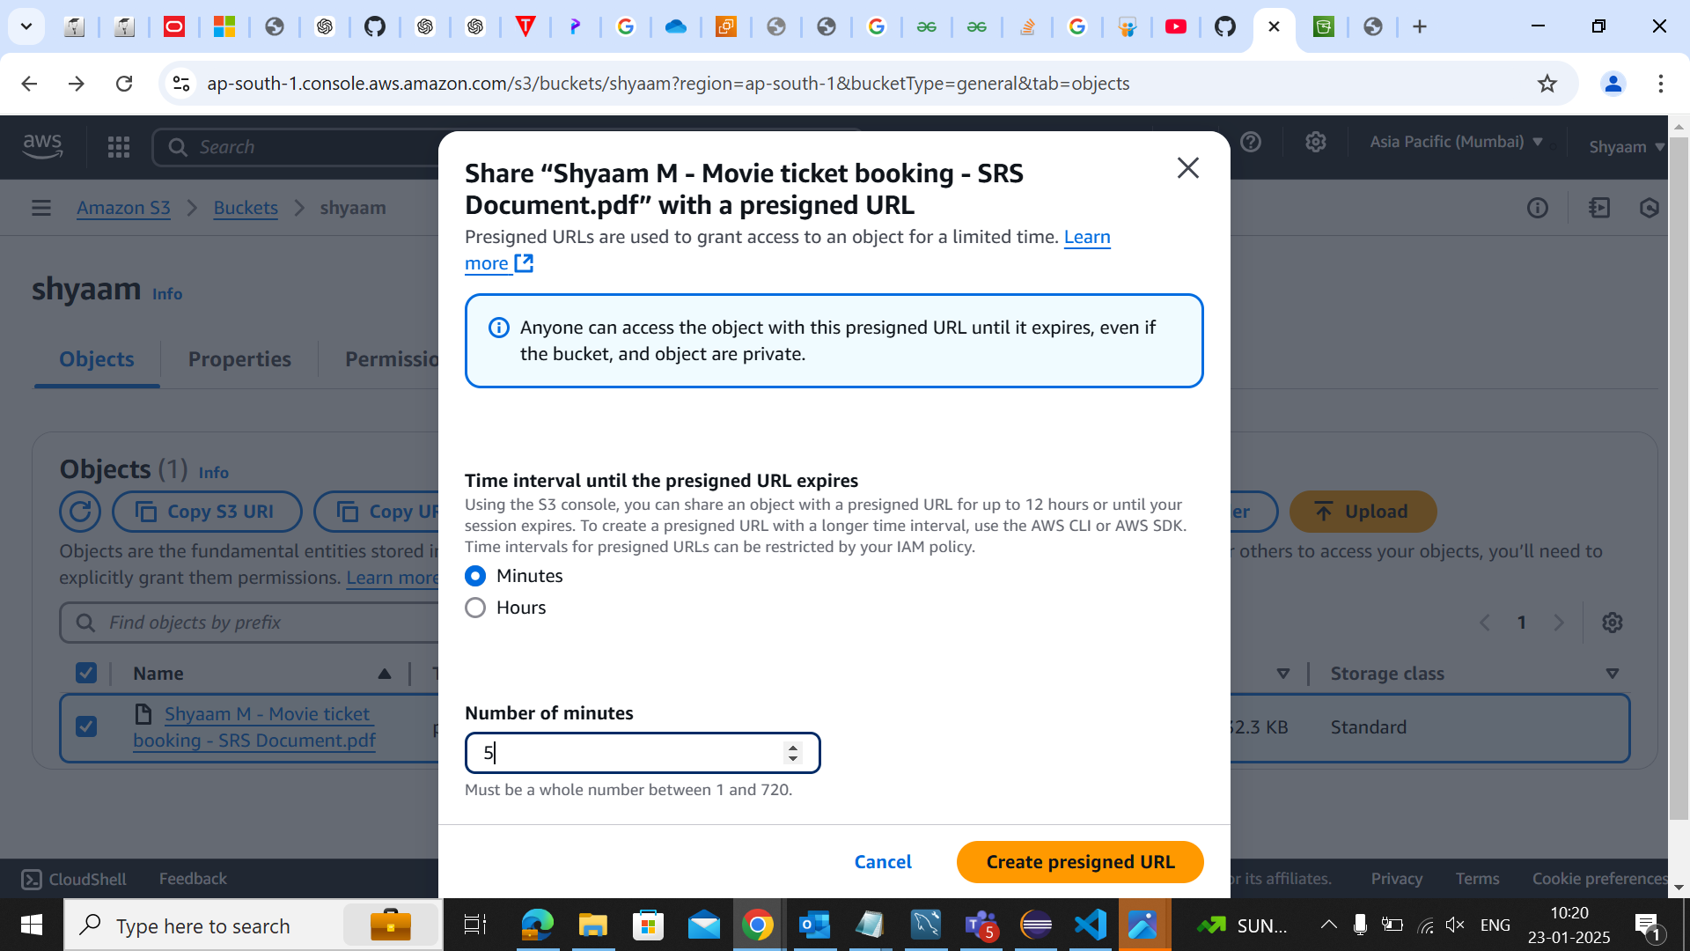

Step 7: Copy the link to display the document

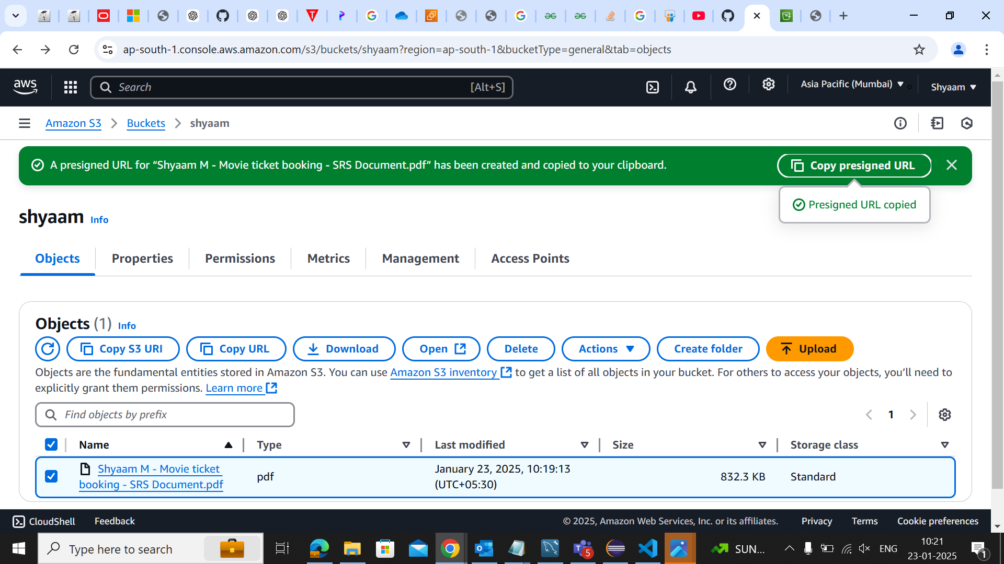

Step 8: Created lifecycle for object creation

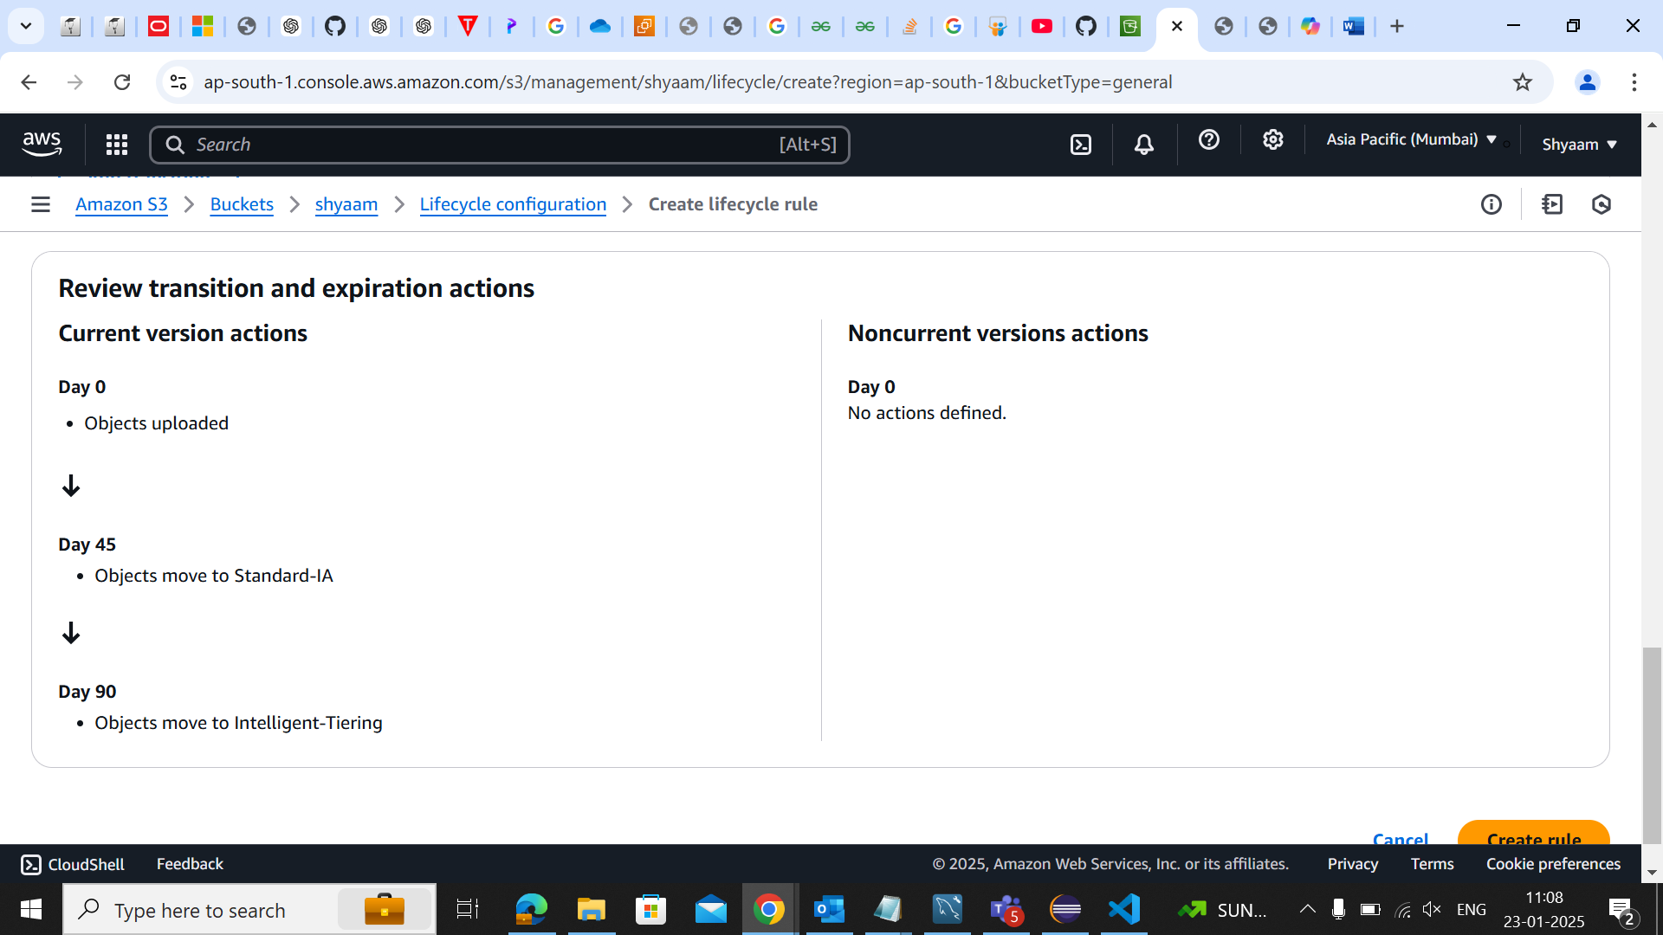

Step 9: Display Document

